**DAILY ONLINE ACTIVITIES SUMMARY**

|  |  |  |  |  |  |  |  |  |
| --- | --- | --- | --- | --- | --- | --- | --- | --- |
| **Date:** | **16-06-2020** | | | | | **Name:** | **SRILATHA K KAMATH** | |
| **Sem & Sec** | **6 B** | | | | | **USN:** | **4AL17CS099** | |
| **Online Test Summary** | | | | | | | | |
| **Subject** | | **Python Workshop Quiz** | | | | | | |
| **Max. Marks** | | **20** | | **Score** | | | **15** | |
| **Certification Course Summary** | | | | | | | | |
| **Course** | 1. **Pre-placement Training** 2. **Python Workshop On DA and ML** | | | | | | | |
| **Certificate Provider** | | | **-** | | **Duration** | | | **4hours** |
| **Coding Challenges** | | | | | | | | |
| **Problem Statement:** Python program to calculate the number of words and the number of characters present in a string. Java program to check if a given tree is BST. Java program to implement Triply Linked List. | | | | | | | | |
| **Status: COMPLETED** | | | | | | | | |
| **Uploaded the report in Github** | | | | | **YES** | | | |
| **If yes Repository name** | | | | | https://github.com/alvas-education-foundation/Srilatha-K-Kamath-Daily-Report.git | | | |
| **Uploaded the report in slack** | | | | | **YES** | | | |

Online Test Details:

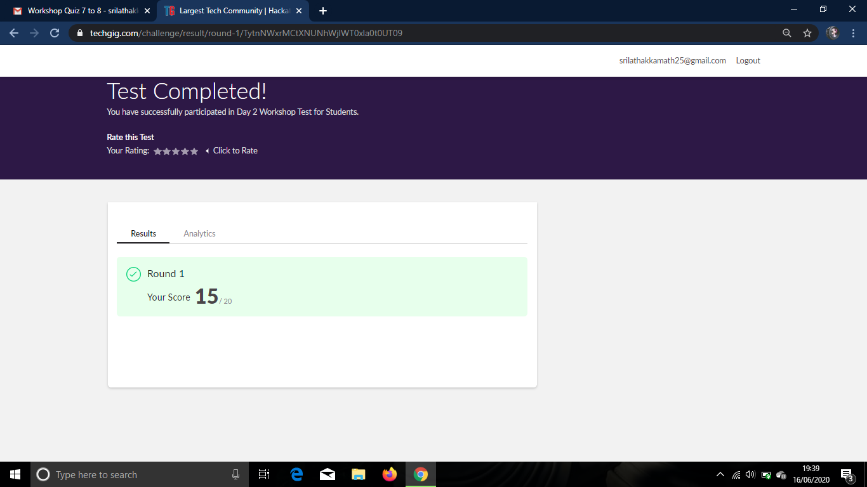

Online Course Details:

Attended class on the topic Programming in C. [from 9am to 11.00am]

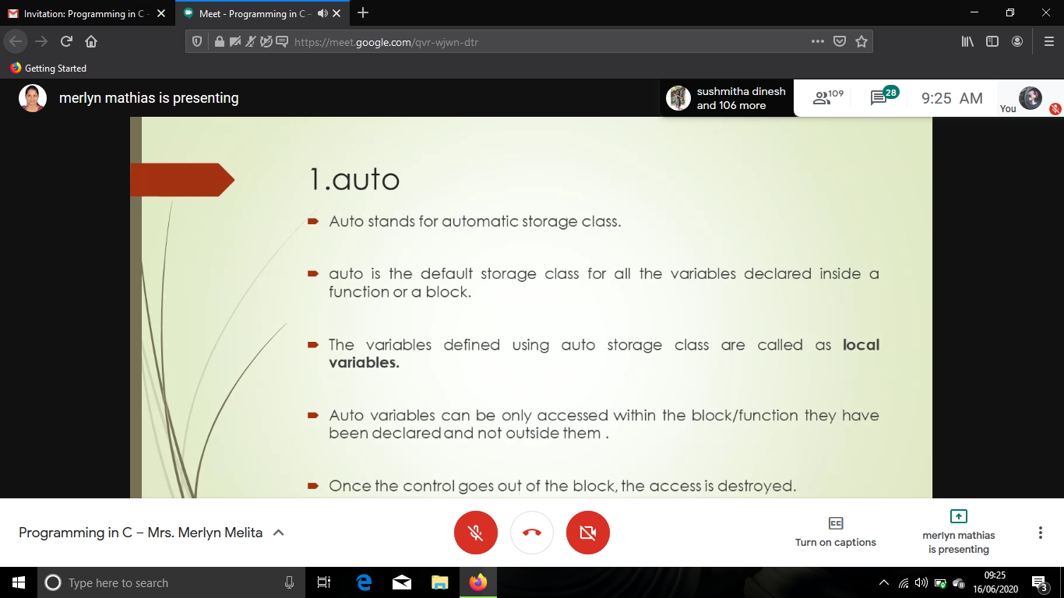

Attended Python Workshop on DA and ML. [from 11.10am to 01.20pm]

Worked out Python programs using Google Colab.

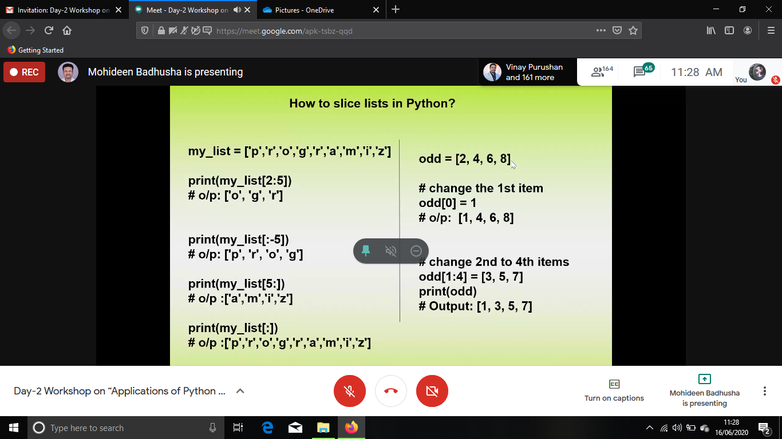

Online Coding Details: Python Program to Calculate the Number of Words and the Number of characters Present in a String.

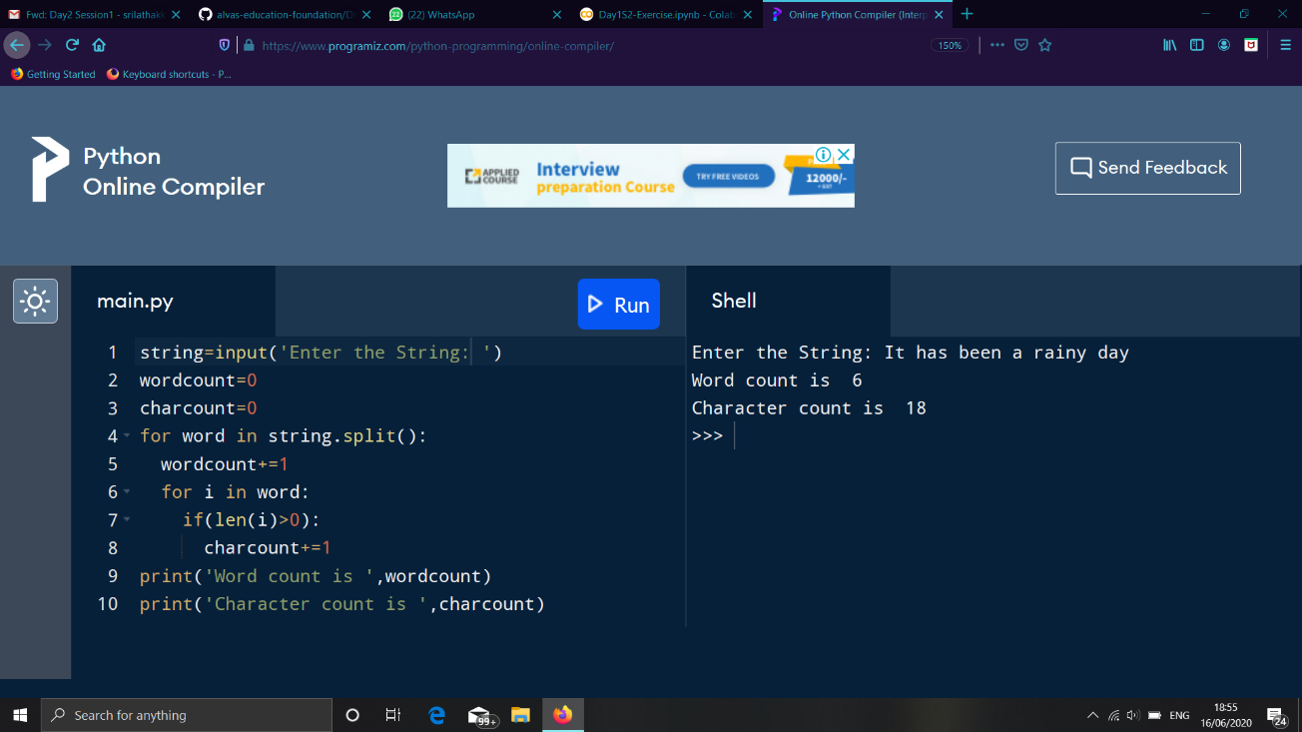

2 Java program to check if a given tree is BST.

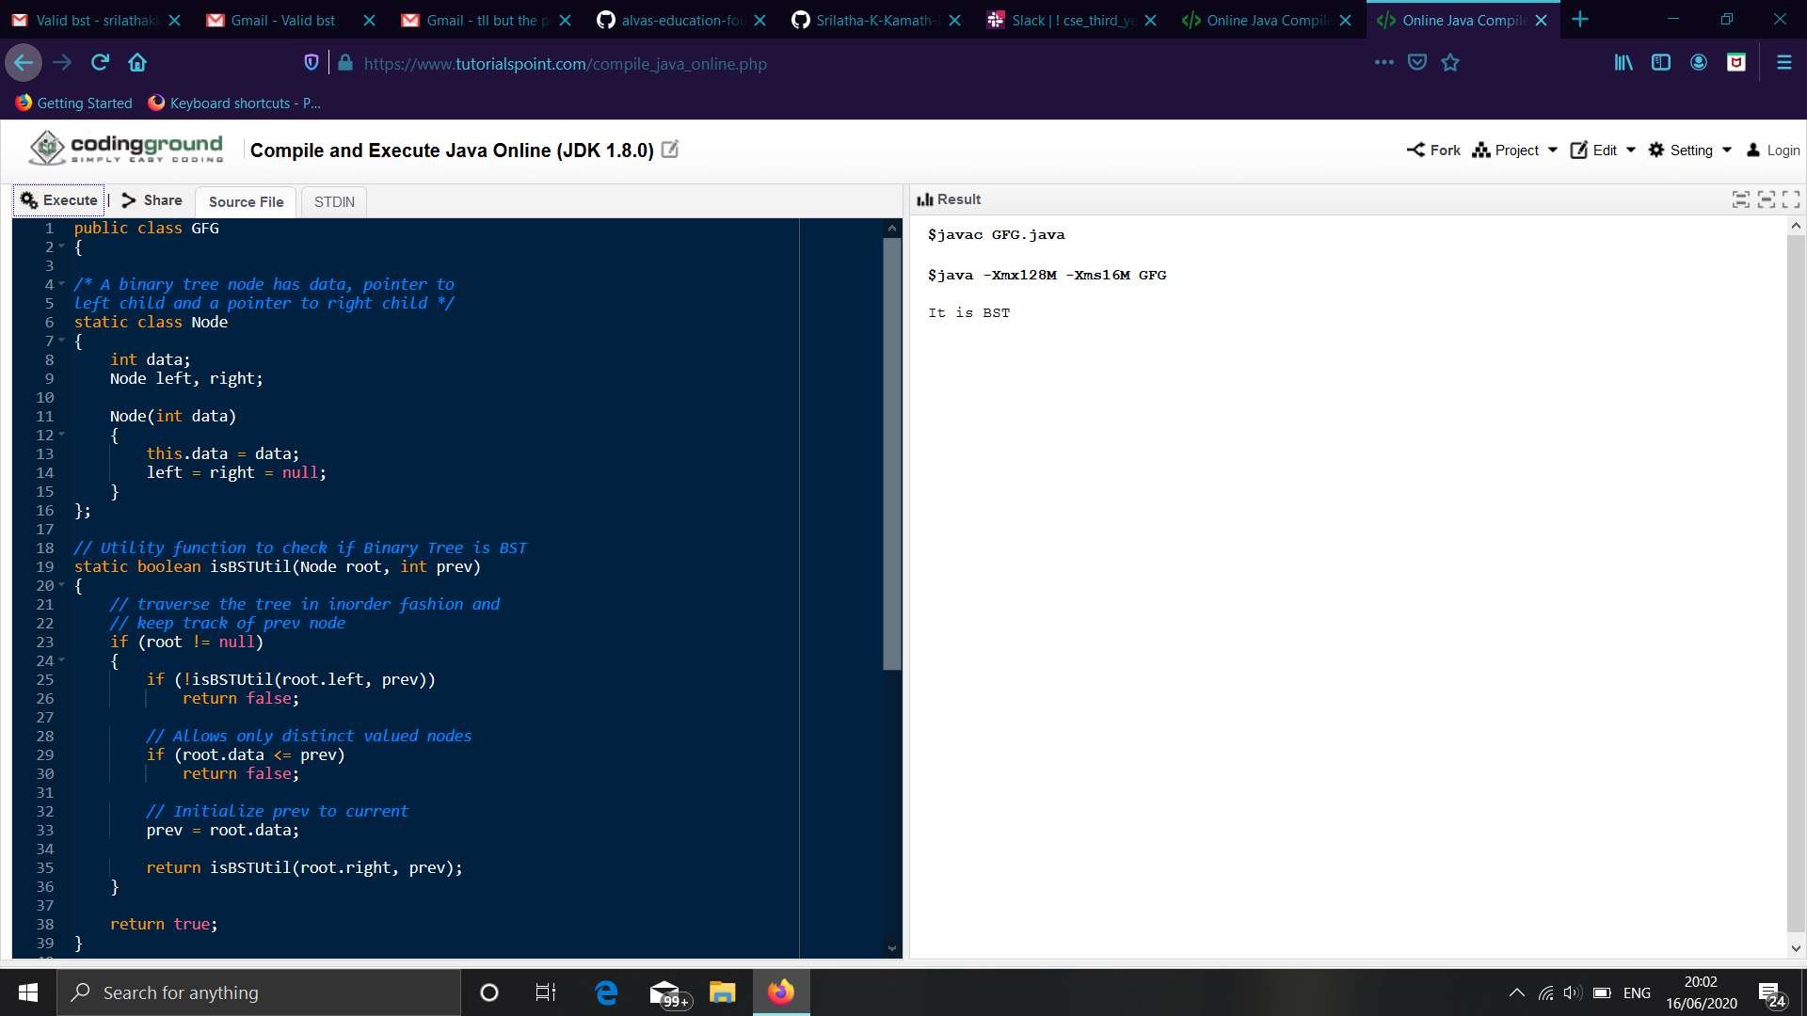

3 Java program to implement Triply Linked List.

